Exercise 3
Web Application using WebStorm

Aim
To create a simple interactive web page using HTML, CSS and JavaScript.
Index.html
<!DOCTYPE html>
<html>
<head>
<title>Electricity Bill Calculator</title>
<link rel="stylesheet" href="style.css">
</head>
<body>
<h1>Electricity Bill Calculator</h1>
<label>Enter Units Consumed:</label>
<input type="number" id="units" placeholder="Enter units">
<button onclick="calculateBill()">Calculate Bill</button>
<h2 id="result"></h2>
<script src="script.js"></script>
</body>
</html>
Style.css
body {
font-family: Arial, sans-serif;
margin: 40px;
}
input {
padding: 8px;
margin: 10px;
}
button {
padding: 8px 15px;
margin-left: 10px;
}
#result {
margin-top: 20px;
}
Script.js
function calculateBill() {
let units = Number(document.getElementById("units").value);
let bill = 0;
if (units <= 100) {
bill = units * 2;
}
else if (units <= 200) {
bill = (100 * 2) + ((units - 100) * 3);
}
else if (units <= 500) {
bill = (100 * 2) + (100 * 3) + ((units - 200) * 5);
}
else {
bill = (100 * 2) + (100 * 3) + (300 * 5)
+ ((units - 500) * 7);
}
document.getElementById("result").innerHTML =
"Total Electricity Bill = Rs." + bill;
}

Procedure
- Create a new WebStorm project.
- Create index.html, style.css and script.js.
- Enter the code in the corresponding files.
- Open index.html using the browser or WebStorm's browser preview.
- Enter a student name and click Add Student.
- Verify that the name appears in the list.
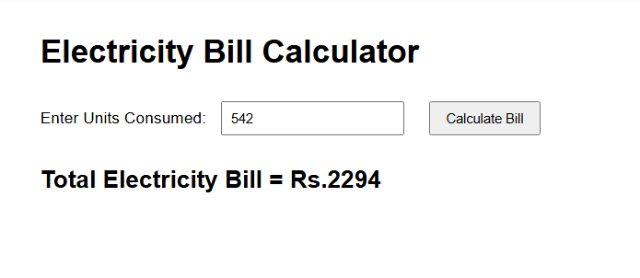

Result
Thus the experiment was successfully performed and the expected result was obtained.

